**Donating blood is an act of solidarity. Join the effort and save lives**

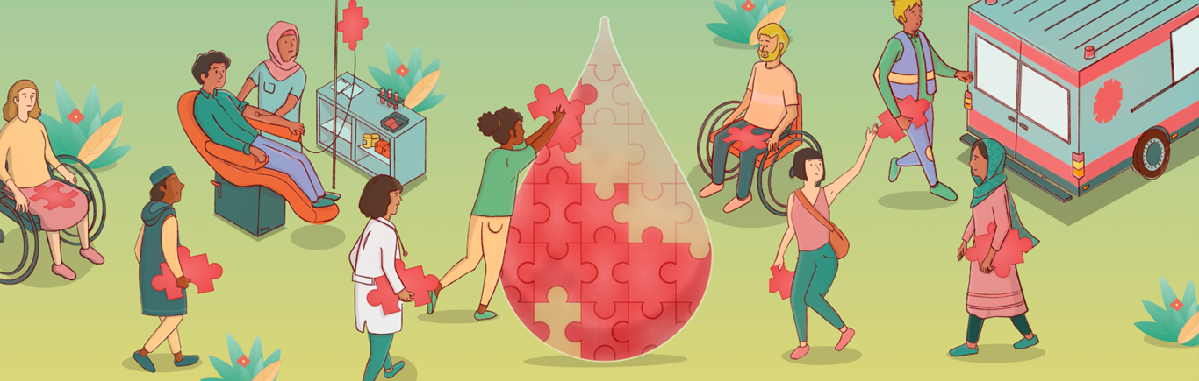

The world record of “HIGHEST BLOOD DONOR" is achieved by Hony Capt Dr. Suresh Kumar Saini from Karnal (Haryana) India on 22nd October 2020. He donated blood 131 times. He also donated platelets for 94 times. Setting a new world record for the international book of records.



1. Annually around 118.5 million units of donated blood are collected globally (2✔  
     
     
   ).
2. A person can donate one unit of blood in one hour, which can be separated into four individual components that can help save multiple lives (3✔  
     
     
   ).
3. According to the World Health Organization (WHO), India suffers from an annual deficit of 2 million blood units, as only 1% of the Indian population donates blood each year.
4. According to the American Red Cross, 36,000 units of red blood cells, 7,000 units of platelets, and 10,000 units of plasma are required daily in the United States.
5. The major human [blood groups](https://www.medindia.net/patientinfo/blood-groups.htm) – A, B, AB, and O were first identified and classified by Dr. Karl Landsteiner in 1901. They cannot be artificially manufactured but can be obtained from generous donors (4✔  
     
     
   ).
6. Red cells, platelets, plasma and cryoprecipitate are the four types of transfusable products that can be derived from blood (5✔  
     
     
   ).
7. Separating the whole blood into its various components can allow a single unit of blood to benefit multiple patients, and this process of donating specific components is called Apheresis (6✔  
     
     
   ).
8. AB+ is the universal acceptor of blood, which means AB+ persons can receive blood from any blood group. While O negative is the universal donor, which means O negative persons can donate blood to persons with any other blood group (7✔  
     
     
   ).
9. Donated platelets must be used within five days and red blood cells must be used within 42 days from the date of collection (8✔  
     
     
   ).
10. Blood products like plasma and cryoprecipitate are stored in a frozen state and thereby can be used for up to one year after collection (9✔  
      
      
    ).
11. All donated blood products have to be screened for HIV, [hepatitis B](https://www.medindia.net/patients/patientinfo/hepatitisb.htm), hepatitis C and syphilis before transfusion (8✔  
      
      
    ).
12. [Blood transfusions](https://www.medindia.net/patients/patientinfo/blood-transfusion.htm) are often used for supportive care in various surgeries. They can also be used in the management of pregnancy-related complications, childhood malaria complicated by severe anemia and trauma-related injuries especially in low- and middle-income countries (10✔  
      
      
    ).
13. Unnecessary transfusions can expose patients to HIV, hepatitis and adverse transfusion reactions (11✔  
      
      
    ).
14. Every year, approximately 300,000 infants are born with thalassemia and sickle-cell disease, and require regular blood transfusions (12✔  
      
      
    ).
15. The minimum time between whole blood donations ranges from 56 days (8 weeks) to 16 weeks. Platelet donations can be made as frequently as every eight day (13✔  
      
      
    ).

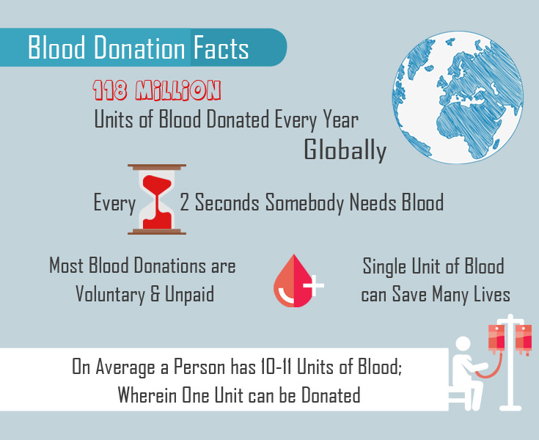

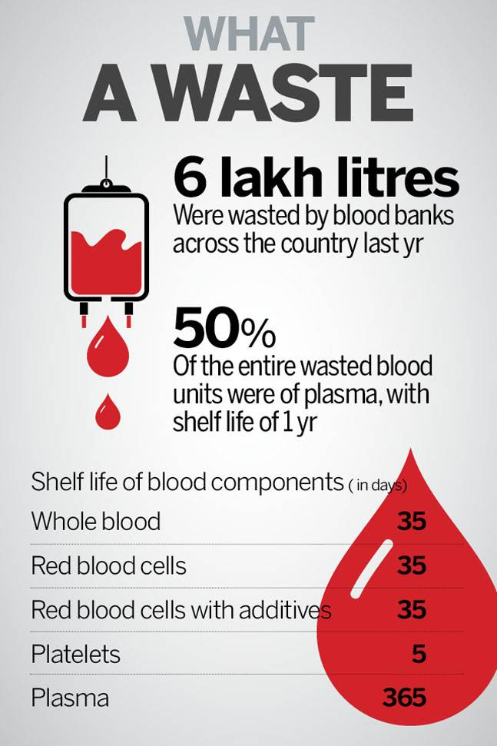

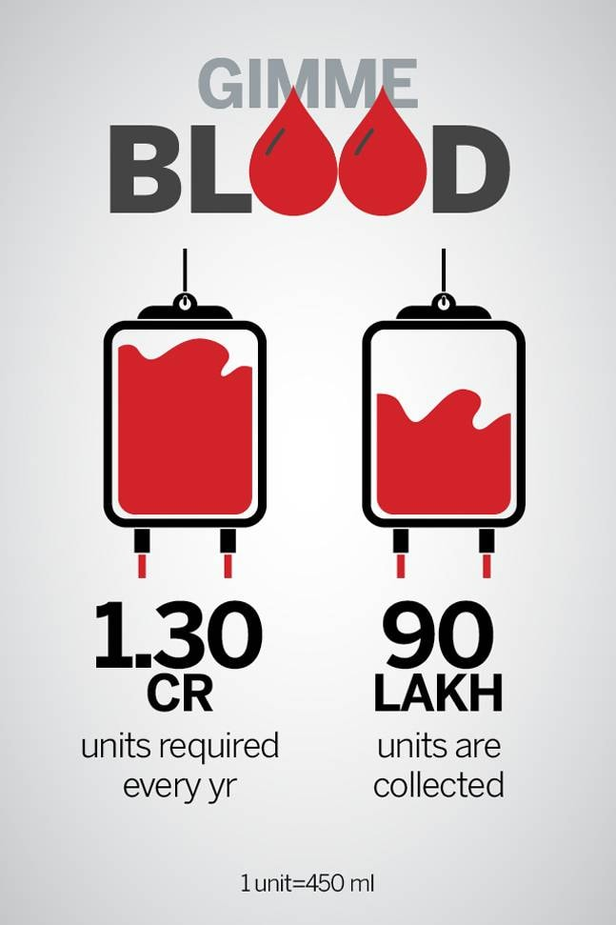

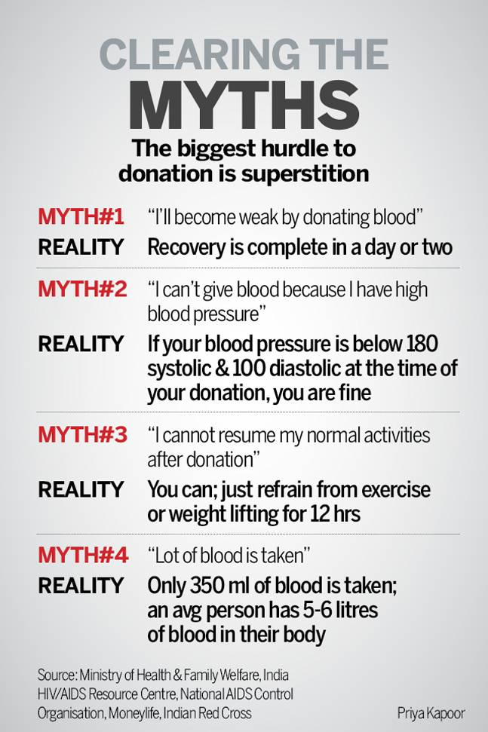

* **If you began donating blood at age 18 and donated every 90 days until you reached 60, you would have donated 30 gallons of blood, potentially helping save more than 500 lives!**
* **Only 7 percent of people in India have O-negative blood type. O-negative blood type donors are universal donors as their blood can be given to people of all blood types**. **Type O-negative blood is needed in emergencies before the patient's blood type is known and with newborns who need blood.**
* **0.4 percent of people have AB-blood type. AB-type blood donors are universal donors of plasma, which is often used in emergencies, for newborns and for patients requiring massive transfusions.**



